CAPABILITY STATEMENT |  | 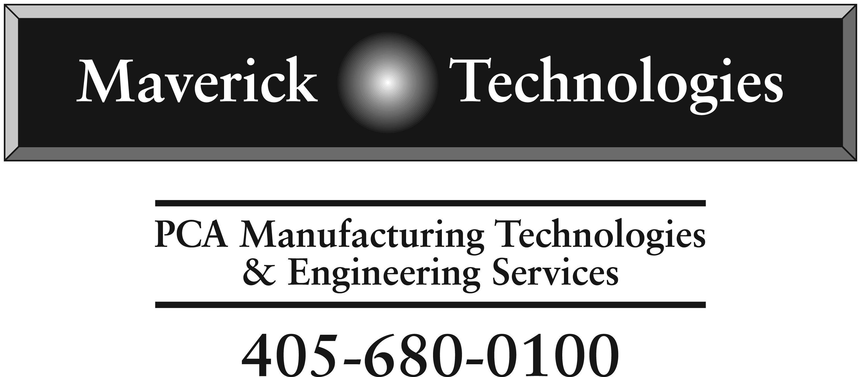
Core Competencies
We are a full service Electronic Design & Manufacturing service company. Our specialty is in designing & manufacturing electronic related products, from system, board, cable systems and mechanical hardware systems.
We are a technology solutions provider.

- Technology driven solutions provider
- Cost competitive solutions based on engineering driven technologies
- Mechatronics/Electronics based technologies
- Design core of engineers supporting a board level up to system level capabilities
- Manufacturing core, SMT, Cable and System Integration
- Quality driven practices and methodologies supporting government practices
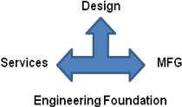
Past Performance |  | Differentiators
Customer related History:  Boeing: -- KC-135 cable test systems  Schlumberger -- WFM cabinet re-design  -- Down-hole safety switch  National Weather Service -- DAU Lightning protection system |  | Our company contains, design, material fulfillment, manufacturing and integration into one operation, which allows innovation and technology solutions at a competitive advantage.
Company Data |  | Pertinent Codes
Maverick Technologies, LLC  - Established: 2003  - Design & Manufacturing base for Local and Regional customers  - DOD, DOT, and Commercial/Industrial Customer base  - USAF, FAA, National Weather Service  - Tactical Electronics  - Boeing  - Oil & Gas Industries  - Power Utility Industries  - Solar/Wind Industries |  | List specific pertinent codes & Certs  - DUNS: 128817546  - NAICS: 334417, 334418, 334419, 541330  - CAGE Code: 3GA37  - JCP Certification: 0038437
Maverick Technologies, LLC 2800 S. Purdue, OKC, OK 73128, PH: 405-680-0-100, Fax: 405-680-0101

